YEAR 11 PHYSICS

PRACTICE EXAM A

Time allowed for this paper:
Reading time before commencing work 10 minutes
Working time for paper 3 hours

Materials required/recommended for this paper
To be provides by the supervisor
This Question/Answer Booklet
Formulae and Data Booklet

To be provided by the candidate
Standard items: pens, pencils (including coloured), sharpener, correction fluid, eraser, ruler, highlighters.
Special items : up to three non-programmable calculators approved for use in the WACE examinations, drawing templates, drawing compass and a protractor.

STRUCTURE OF THE PAPER

Section | No. of  Questions | No. of questions  to be attempted | Suggested working time  (minutes) | Marks available | Proportion of  exam total
1: Short Answers | 15 | ALL | 50 | 54 | 30%
2: Problem Solving | 9 | ALL | 90 | 90 | 50%
3: Comprehension and  Interpretation | 2 | ALL | 40 | 36 | 20%

INSTRUCTIONS TO CANDIDATES

Write your answers in the spaces provided beneath each question. The value of each question (out of 180) is shown following each question.

Calculators satisfying conditions set by the School Curriculum and Standards Authority may be used to evaluate numerical answers. The calculator cannot be a “graphics” calculator.

Answers to questions involving calculations should be evaluated and given in decimal form. Final answers should be given to three significant figures and include appropriate units where appropriate. Despite an incorrect final result, credit may be obtained for method and working providing these are clearly and legibly set out.

Questions containing specific instructions to show working should be answered with a complete, logical, clear sequence of reasoning showing how the final answer was arrived at; correct answers which do not show working will not be awarded full marks.

Questions containing the instruction "ESTIMATE" may give insufficient numerical data for their solution. Show your working or reasoning clearly. Give final answers to two significant figures and include appropriate units where applicable.

SECTION ONE – SHORT RESPONSE

Marks allocated: 54 marks out of a total of 180 (30%)

This section has 15 questions. Answer all questions.
Answers are to be written in the space below or next to each question.
Suggested working time: 50 minutes
Question 1 (4 marks)
In the context of heat transfer explain how conduction and convection differ from radiation using the kinetic theory of matter.

Question 2 (3 marks)
How much heat would be absorbed by a person’s skin if they were to come into contact with 10.0 g of steam at 100°C? (skin temperature is 37 ºC).

Question 3 (4 marks)
(a) Sketch a diagram of a circuit that has a total resistance of 15.0 Ω, consisting of only 10 Ω
resistors. Include a power supply and a switch in the circuit (2 marks)

(b) Calculate the potential difference required to provide a total current of 1.5 A through the circuit. (2 marks)

Question 4 (4 marks)
You are given two samples of radioactive waste.

 | Sample A | Sample B
Radioactive constituent | strontium - 90 | hydrogen - 3
Amount of material | 6.0 x 1020 atoms | 6.0 x 1020 atoms
Half-life | 29 years | 12 years
Emission type | High energy β - particles | Low energy β - particles
Does this material accumulate in the body? | Yes. Deposits in bone, close to marrow. | Yes. Fairly even distribution over the body.

(a) Which of the two samples would have the higher activity? Explain. (2 marks)

(b) Which of the two samples would pose the greater health risk due to radiation if accidentally
swallowed? Explain. (2 marks)

Question 5 (4 marks)
Given only a 6.00 Ω resistor and a 3.00 Ω resistor, and connecting wires draw two (2) separate circuit diagrams to show how the resistors would be joined to give a combined resistance of:

(a) 9.00 Ω (2 marks)

(b) 2.00 Ω (2 marks)

Question 6 (3 marks)

An experimental sun cream is applied to an athlete’s face to protect against sunburn. If on average 10.0 g of the cream is applied to the face (at a temperature of 37.0°C) in a standard application, calculate how much heat could be absorbed as the temperature of the skin increases by 8.0 °C.
(The heat specifications of the cream are: c_{solid} = 8.50 x 10² J kg⁻¹ K⁻¹ and L_{f} = 1.64 x 10³ J kg⁻¹.
and MP = 45.0 ^{O}C)

Question 7 (5 marks)

Complete each of the following:

- A___________________________ is a self sustaining process that may be controlled to

produce thermal energy.

(b) ______________________________ is a reaction in which light nuclides combine to form a

heavier nuclide.

(c) _____________________________ is released per nucleon in nuclear fusion than in nuclear

fission.

(d) Each species of radio nuclide has a half life which indicates the rate of ____________

(e) Neutron - induced nuclear fission is a reaction in which a heavy nuclide captures a neutron

and then splits into smaller ___________________nuclides with the release of energy.

Question 8 (4 marks)
A cricketer is fielding on a very hot day. She calls for a runner to bring her a towel soaked in water. She places the towel on her head and after a short time she feels the cooling effect of the towel.

(a) Briefly explain how a wet towel can keep a person cool? (2 marks)

(b) Explain how the effectiveness of the wet towel would change in humid conditions.
(1 mark)

(c) State one factor that could be changed to increase the rate of cooling. (1 mark)

Question 9 (4 marks)
While checking for radioactive leaks, a worker discovers a drum of what he thinks is radioactive waste. When tested at a set distance the reading on his detector measures 242 Bq. If the half life of the waste is 5.0 x 10⁴ years, calculate how long it will take to produce a reading of 8.0 Bq.
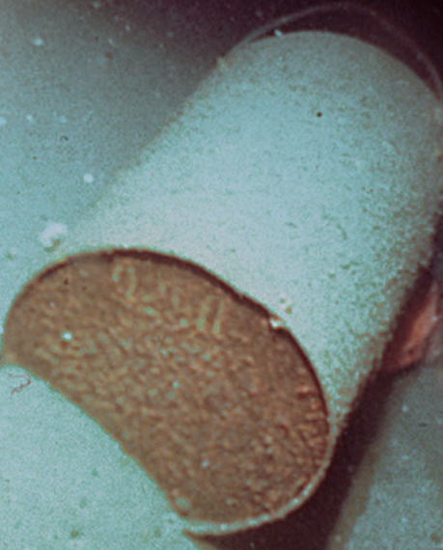

Question 10 (3 marks)
Explain the concept of electrical current and explain how an electrical current is established.

Question 11 (3 marks)
Measurements of current flowing through a non-ohmic conductor as the potential difference is changed, are recorded and graphed. The graph is below.

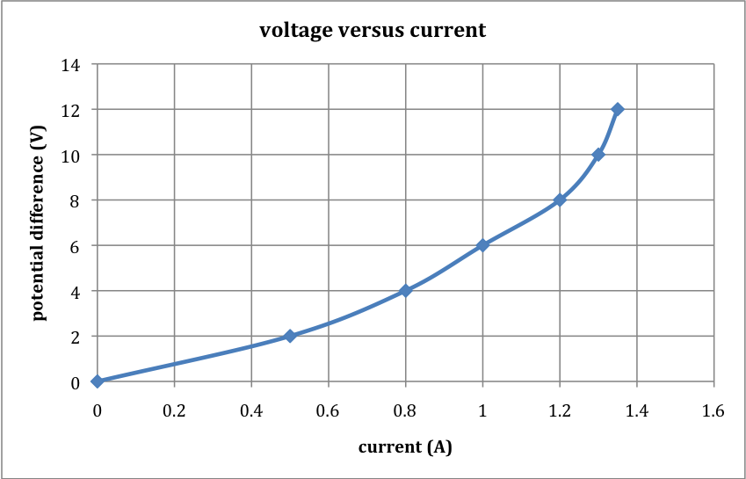

(a) Explain what is meant by the term ‘non-ohmic’. (2 marks)

(b) Using the graph determine the resistance when the potential difference is 10.0 V. (1 mark)

Question 12 (3 marks)

A geology student decides to measure the specific heat capacity of a sample of molten rock using the following steps. He:
- Prepares a bucket of water.
- Measures the temperature of the water.
- Records the mass of the bucket plus water.
- Plunges the molten rock into the water.
- Measures the final temperature of the water.
- Measures the combined mass of the bucket, water and solidified rock.
- Performs a calculation using Heat gained = Heat lost, and the formula Q = m c ΔT

State 3 reasons why this method would NOT give an accurate result.

Question 13 (2 marks)

The radiation emitted by the isotope Caesium – 137 can be used to treat food to increase its shelf life. Calculate the amount of energy absorbed by 2.00 kg of meat when it is given a dose of
2500 Gy.

Question 14 (5 marks)

(a) In the spaces below draw two circuit diagrams which consist of one 1.5 V cell powering two light globes.
Circuit 1: Two globes in series with the 1.5 V cell.
Circuit 2: Two globes in parallel with the 1.5 V cell.

Circuit 1: Series circuit (1 mark) | Circuit 2: Parallel circuit (1 mark)

(b) If the components in each of the circuits are identical, which circuit will have the brighter light globes? (1 mark)

(c) Explain your answer to (b). (2 marks)

Question 15 (3 marks)
The radioisotope iodine -131 is used in medicine to treat some cancers. It has a half- life of
8.1 days. It decays into an isotope of xenon (Xe) by beta emission.
- Write an equation that represents this decay.

Equation ________________________________________ (2 marks)

(b) In terms of half life explain why iodine is useful in this application. (1 mark)

END OF SECTION ONE

SECTION TWO QUESTIONS

Section Two: Problem-Solving 50% (90 marks)

This section contains 9 questions. Suggested working time 90 minutes
Answer the questions in the spaces provided.

Question 16 (14 marks)
Two light globes are connected in a parallel circuit connected to the mains supply (240 V), as shown in the diagram below. Globe X has a resistance of 300.0 Ω and globe Y a resistance of 800.0 Ω.
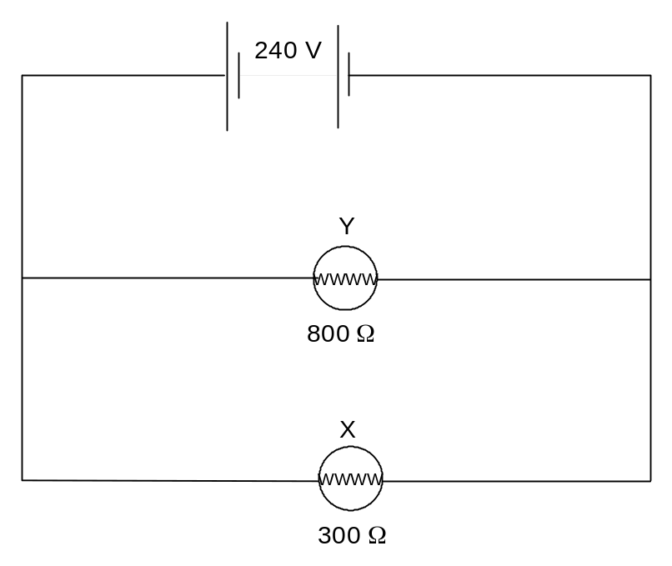
(a) When the globes are switched on together, calculate how much current is drawn by:
Globe X (2 marks)

Globe Y (2 marks)

(b) Calculate the total current drawn by the globes when they are switched on together. (2 marks)

(c) Would the total current drawn by the globes, when they are switched on together, be likely to cause
a fuse to blow or a safety device to trip in the main fuse box of the house? Explain your answer. (2 marks)

(d) Calculate the total resistance in the circuit. (2 marks)

(e) Calculate the cost of operating the globes for 2.0 hours if they were both switched on together and
the cost of electricity was 22.36 cents per kWh. (4 marks)

Question 17 (10 marks)
A careless research student at a university, accidentally swallowed a radioisotope with an activity of 10.0 kBq. The material swallowed has a very long effective half-life, so assume that the activity will not change appreciably during the student’s lifetime. Each decay of the isotope releases 1.55 x 10-13 J of energy into the body. Also assume that all of the energy is absorbed by the student’s body and that the radioisotope is not eliminated.
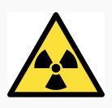

(a) Calculate the amount of energy absorbed in one year. (1 year = 365 days) (2 marks)

(b) If the student has a mass 55.0 kg, determine the energy absorbed per kg in one year.
(2 marks)

(c) Calculate the absorbed radiation dose in grays per year. (2 marks)

(d) Assume that the ingested radioisotope is an alpha emitter.
(i) What is the equivalent absorbed radiation per year? (2 marks)

(ii) Should the student be concerned about his yearly radiation exposure?
Justify your answer. (2 marks)

Question 18 (7 marks)
A student heated a 750.0 g solid sample in an insulated container. An electric heating coil supplied heat energy at a rate of 20.0 J s⁻¹. She measured the temperature of the substance at half-minute intervals. The data was then graphed as shown below.
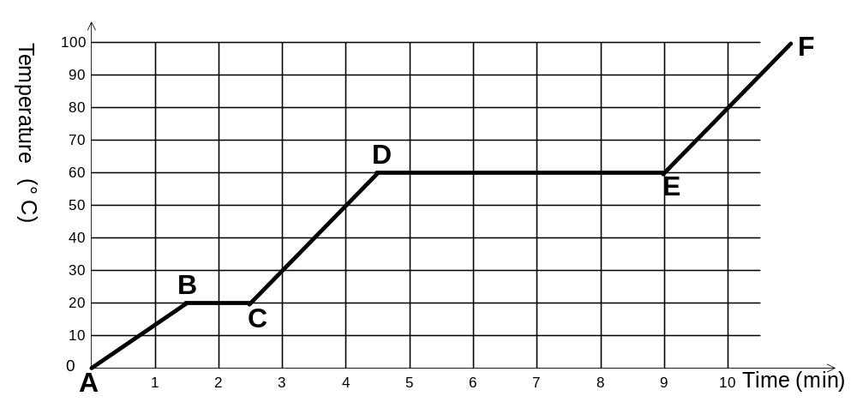

(a) Which section (A-B, B-C, etc) of the graph represents: (2 marks)

(i) the solid warming up to its melting point?

(ii) the gaseous substance increasing in temperature?

(b) Which sections of the graph represent stages where: (2 marks)

(i) the average kinetic energy of the particles was increasing?

(ii) the potential energy of the particles was increasing, whilst their kinetic energies remained
constant?

(c) ESTIMATE the quantity of heat required to convert 1.0 kg of the solid, at its melting point, to a
liquid. (3 marks)

Question 19 (13 marks)
In order to determine the specific heat of an unknown liquid students were encouraged to first find the heat generated by a Bunsen burner flame and then, later, using that same flame to heat a known mass of the unknown liquid. A diagram of the apparatus is shown below.

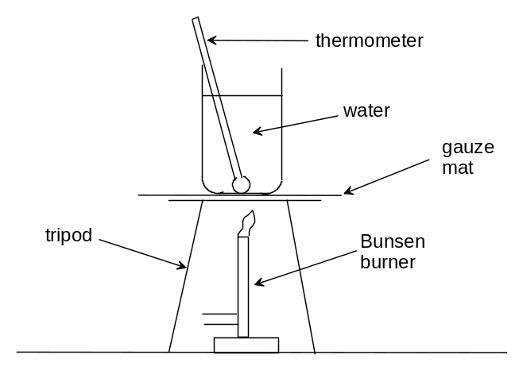

(a) List two good techniques a student would perform in this preliminary part of the experiment.
(2 marks)

Initially the water was heated with the Bunsen burner and the temperature rise recorded.

Mass of water (kg) | 0.50
Initial Temp of water ( ⁰C) | 23.0
Final Temp of water ( ⁰C) | 57.0
Change in temp of water ( ⁰C)
Time for which water was heated (s) | 260.0

(b) Calculate the quantity of heat generated by the Bunsen burner assuming no loss of energy to the
surroundings. (1 mark)

(c) Calculate the average power of the Bunsen burner. (2 marks)

(d) Before replacing the water with the unknown liquid the student was asked to list the main sources
of error while calculating the power of the Bunsen burner flame. List two possible sources of error. (2 marks)

The water was replaced by the unknown liquid and the procedure repeated. The results were
recorded in the table below.

Mass of unknown liquid (kg) | 0.41
Initial Temp of unknown liquid (⁰C) | 23.0
Final Temp of unknown liquid (⁰C) | 66.0
Change in temp of unknown liquid (⁰C)
Time that unknown liquid was heated (s) | 120.0

(e) In order for the results to be accurate, list two conditions that the students should
have taken care to duplicate. (2 marks)

(f) Determine the specific heat of the unknown liquid showing all your calculations. (4 marks)

Question 20 (10 marks)

The diagram below shows a schematic view of a nuclear power plant that underwent meltdown in the 1970s.
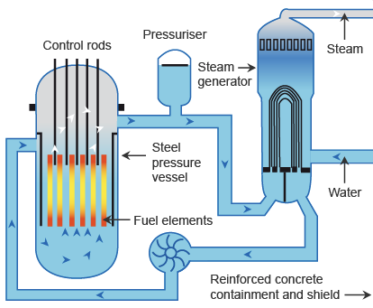
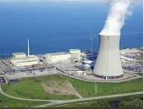

(a) Explain the purpose of the control rods, and how they are used to achieve their purpose.
(2 marks)

(b) Initial radiation exposure in contaminated areas of the reactor was due to short-lived iodine-131;
later caesium-137 was the main hazard. 93.5% of the Cs-137 parent isotope beta decays to Ba-137
with a half life of 30.17 years. In turn the Ba-137 decays with a half-life of 2.55 minutes, emitting
gamma radiation.

(i) Write a decay equation to represent the major decay of Cs-137 to Ba-137. (1 mark)

(ii) Write a decay equation to represent the decay of Ba – 137 when it has a half life of
2.55 minutes (1 mark)

The major fuel source for the reactor was enriched uranium containing 1.8% U-235, which underwent decay by a series of different reactions to produce 950 MW of electrical energy output.

(c) Calculate the mass of U-235 that underwent decay in the reactor every day, assuming that it operated at 40% efficiency.
(One U-235 nucleus has a mass 3.90625 x 10⁻²³ kg, and one decay event releases 200 MeV of
energy.) (6 marks)

Question 21 (8 marks)
During a severe storm the potential difference between a cloud and the Earth is about 1.00 x 10⁹ V.
This results in a lightning flash during which 40.0 C of charge flows in 1.11 x 10⁻² seconds.

(a) Calculate the amount of energy dissipated. (3 marks)

(b) Calculate the average current. (3 marks)

(c) If you wanted to avoid being struck by lightning during such a storm, what preventative action
could you take? (2 marks)

Question 22 (11 marks)
The Carbon-Nitrogen-Oxygen (CNO) cycle is a complex set of fusion reactions by which stars convert hydrogen to helium. One of the reactions in the CNO cycle is shown below.

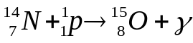

(a) Use the data in the table below to calculate the energy (in MeV) released in this reaction.
(2 marks)

Particle | Nitrogen-14 | Proton | Oxygen-15
Mass (u) | 13.999234 | 1.00728 | 14.998677

(b) Mass is converted to energy in nuclear reactions. In what form(s) could this energy exist?
Describe two examples. (2 marks)

The graph below shows the binding energy per nucleon versus mass number for the nuclei of some common isotopes.

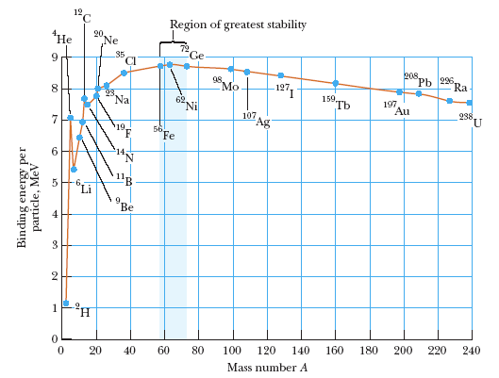

(c) In the context of nuclear physics, what does binding energy measure? (2 marks)

(d) The oxygen-16 nucleus has a mass of 15.990526 u, a proton has a mass of 1.00728 u and a neutron
has a mass of 1.00867 u. Calculate the average binding energy per nucleon for the oxygen-16
nucleus in MeV. (3 marks)

(e) Does your answer agree with the accepted value for the average binding energy per nucleon for the oxygen-16 nucleus? Explain your answer by making reference to the graph above. (2 marks)

Question 23 (11 marks)
A simplified diagram of a refrigerative air-conditioner for a house is shown below. A low boiling point, volatile hydrocarbon, called the refrigerant, is circulated through the pipes of the air-conditioner unit.

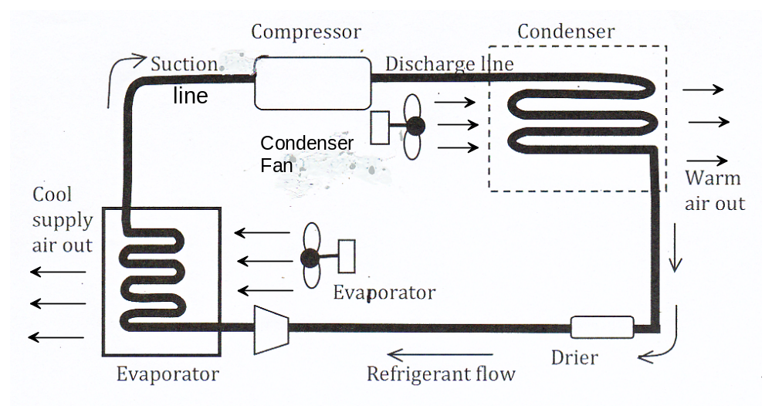

(a) As the refrigerant follows the suction line it enters the compressor. Describe the changes in
temperature, pressure and physical state of the refrigerant as it leaves the compressor and enters the
condenser. Your answer must refer to the latent heat of vaporisation of the refrigerant.
(2 marks)

(b) Where is the condenser unit placed in relation to the layout of the house? (1 mark)

(c) What is the purpose of the condenser fan? (1 mark)

(d) The expansion valve is not shown on this diagram. Explain where it would be placed in the circuit
and also explain its function. (2 marks)

(e) Explain the role of latent heat of vaporisation within the evaporator unit and explain how cool air is
supplied to the house. (3 marks)

(f) Describe 2 separate factors that should be considered when choosing a suitable refrigerant for this
type of air conditioner. (2 marks)

Question 24 (6 marks)
(a) Use calculations to demonstrate which has the greater resistance, a 60 W lamp or a 75 W lamp,
used in a 240 V mains supply. (4 marks)

(b) 75 W lamps are gradually being replaced with “smart” lamps that manufacturers claim deliver the
same power as the older incandescent globe. The new “smart” lamp has a rating of about 18 W.
Describe two advantages of “smart” lamps compared to incandescent lamps. (2 marks)

END OF SECTION TWO

SECTION THREE QUESTIONS

Marks allocated: 36 marks out of a total of 180 (20 %)
This section has two questions. Answer both questions. Answers should be written in the spaces provided.
Suggested working time – 40 minutes.

Question 25 (18 marks)
Thermal Conductivity
Conduction as heat transfer takes place if there is a temperature gradient in a solid or stationary fluid medium.
Energy transfers from more energetic to less energetic molecules when neighboring molecules collide. Heat flows in the direction of decreasing temperatures since higher temperatures are associated with higher molecular energy.
Metals have a higher heat transferability, or thermal conductivity, than wood. If you want to keep something cold the best idea is to wrap it in something that does not have a high heat transferability, or high thermal conductivity, this would be an insulator. Ceramics, and polymers are usually good insulators, but you have to remember that polymers usually have a very low melting temperature. That means if you are designing something that will get very hot the polymer might melt, depending on its melting temperature.

The coefficient of thermal conductivity (k) is a constant value that is assigned to materials that conduct heat and it varies from material to material. The coefficient can be calculated using an equation based on Fourier’s Law. The equation expresses conductive heat transfer.

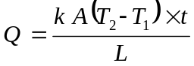…………………………….. equation 1

where
Q = heat transfer (J)
A = heat transfer area (m²)
k = thermal conductivity of the material Wm⁻¹ ºC⁻¹
(T₂ – T₁) = temperature difference across the material ( ºC)
t = time (s)
L = material length (m)

If a metal is to be investigated for its coefficient of thermal conductivity then values of Q, A, T₂, T₁, t and L need to be measured and manipulated in the Fourier Equation. (equation 1).
Rather than taking just one measurement of the variables, researchers usually take a number of measurements and use graphing techniques to arrive at the final value for k. In reality, a computer is used to process the data to produce the value.
Below is a set of measurements that have been recorded by a team of students in an effort to calculate the coefficient of thermal conductivity of a metal.

In this investigation the following results were obtained and tabulated. The metal bar to be investigated had length of 0.75 m, a cross sectional area of 0.035 m² and each trial was performed for 2.0 minutes.

(a) Complete the right hand column with the values for Τ₂ − Τ₁ (2 marks)
Heat in (Q)  (J x 10 ⁵) | Temperature  Τ₂ (ºC) | Temperature  Τ₁ (ºC) | Τ₂ − Τ₁
7.6 | 80 | 55
3.8 | 70 | 57
2.2 | 55 | 49
2.9 | 40 | 31
4.5 | 35 | 20

(b) Plot a graph of Heat in (y axis) against Temperature difference (Τ₂ − Τ₁) (x axis).
(4 marks)


(c) Use the graph to calculate a value for k, the thermal conductivity for this metal. (7 marks)

(d) Suggest a major variable that must be controlled for in performing this type of investigation.
(2 marks)

(e) Explain why researchers and scientists in general choose to perform more than one trial when
determining a final value. (2 marks)

(f) Suggest why polymers may be unsuitable to be used as an insulating material during this experiment. (1 mark)

Question 26 (18 marks)

Electric Vehicles

Vehicles powered by the internal combustion engine (ICE) have been in use for over a century. The operating principles of the engine are practically unchanged and they are still very inefficient. Alternative forms of propulsion are now receiving serious consideration. Australian motorists are gradually becoming more interested in electric vehicles.

Earth’s finite energy resources are being used unsustainably and urban transport plays a major role in energy wastage and pollution that contributes to climate change. The cost of fossil fuels and the dramatic improvement in the performance, price and lifecycle of batteries are making a compelling case for Electric Vehicles.

Hybrid vehicles recently entered the Australian market. They have both a fuel burning engine and an electric motor with a small battery that is recharged by the engine. A full battery Electric Vehicle (EV) has an electric drive system only and is powered entirely by batteries.

The comparatively affordable technology required for Electric Vehicles is ready now. It is a solution that produces zero emissions, has the highest motor-to-wheel efficiency and requires minimal support infrastructure.
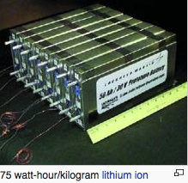
The main components of an Electric Vehicle are:

Battery - lithium-ion technology as used in mobile telephones and laptop computers which can provide a typical range of up to 300 km.

Electric Motor – drives the wheels with high torque, giving sports car like performance, but with a very low noise level and smooth delivery.

Regenerative Braking System - energy is recovered when the vehicle brakes are applied is used to recharge the battery.

Computerised Management System - controls all electrical systems to ensure optimal performance and durability of the battery. It also allows charging to be synchronised with off-peak electricity.
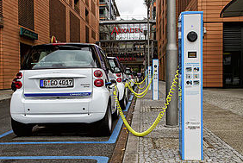
Charging socket – can be connected to a normal 240 V AC household outlet to recharge the battery in typically six to eight hours. Many councils are considering providing charging stations within cities.

Until the production volume of EVs rises significantly they will be more expensive to manufacture compared to similar sized petrol cars. Electric vehicles allow savings of up to 90% on fuel expenses and 50% on maintenance costs which makes them viable when all costs are considered.
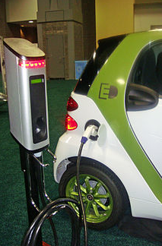
A perceived financial risk is the lifetime and expense of the battery so some manufacturers may opt for leasing the vehicle rather than outright purchase or leasing the battery pack alone.

The main drawback of an EV over conventional ICE vehicles is the limited range and the time taken to recharge the battery. However, studies have shown that 99% of urban users travel less than 150 km per day.

So when used as an urban vehicle that can be charged overnight, drivers should be able to adapt quickly and enjoy the benefits of this mode of transport. The EV may be the car of the future for many Australian families.

(a) State 2 advantages of an EV over an ICE vehicle. (2 marks)

(b) Explain why an EV is more suited to urban driving rather than cross-country trips. (2 marks)

(c) Explain why braking is more efficient on an EV compared to a conventional ICE car by describing
the energy transformations in each case. (2 marks)

(d) A certain EV has an electric motor with a maximum electrical power rating of 50 kW.
Over a 7.0 minute driving cycle at full power engineers measured 1.90  10⁷ J of
mechanical energy available at the driven wheels. Calculate the efficiency of the electric
motor. (3 marks)

(e) A certain lithium-ion battery pack has an energy capacity of 56.1 kW hours. It takes 8 hours
to recharge the battery from empty. Calculate the current in the charging socket from a 240 V
household supply assuming 100% efficiency and a steady rate of charge.
(1 kW hour = 3.60 MJ) (3 marks)

(f) The cost of electricity from Synergy is 22.36 cents per kilowatt hour. Calculate how much it will
cost to recharge the battery with a capacity of 56.1 kW hours. (2 marks)

(g) A group of high school students with an interest in electric vehicles decided to build a vehicle out of
simple electrical components. Below is a simple diagrammatic representation of their vehicle,
viewed from above. Draw on the diagram to show how they would connect the components so
the two motors operate in parallel with each other. Include in the circuit the following additional
components: “on / off” switch, drivers “accelerator” switch and variable resistor to regulate speed. (4 marks)
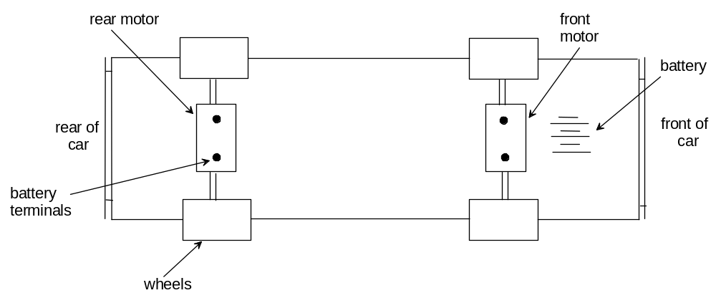

END OF SECTION THREE

